ASSIGNMENT NO 7
1)Write a query that lists each order number followed by the name of
the customer who made the order.
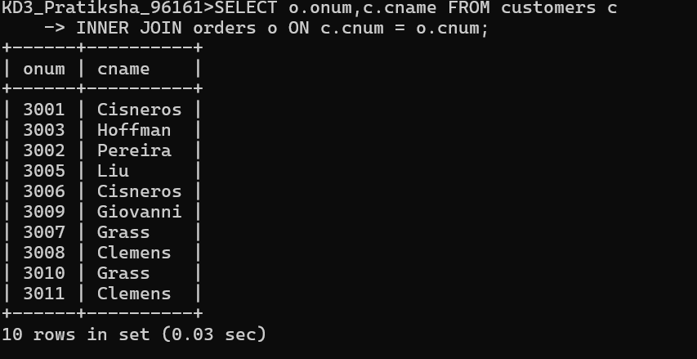
2) Write a query that gives the names of both the salesperson and
the customer for each order along with the order number.
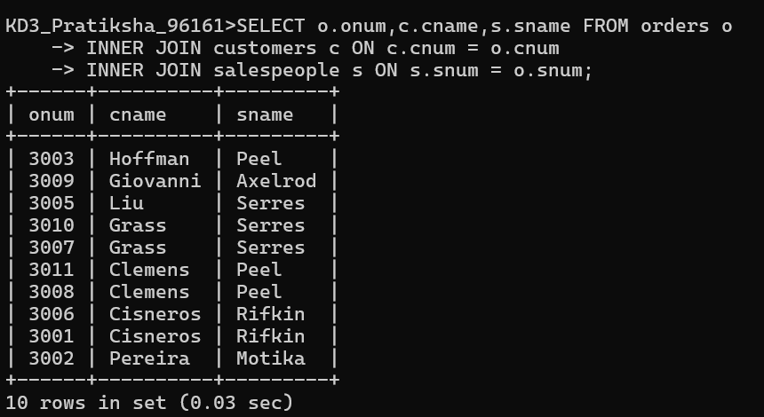

3) Write a query that produces all customers serviced by salespeople
with a commission above 12%. Display the customer’s name, the
salesperson’s name, and the salesperson’s rate of commission.
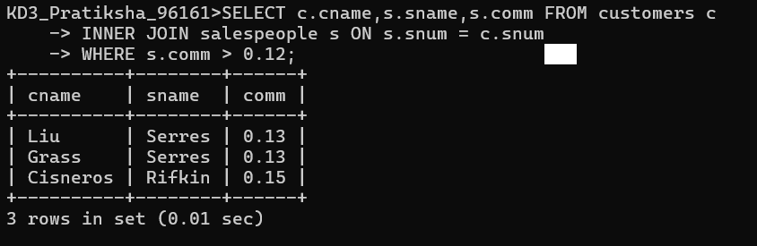

4) Write a query that calculates the commission earned by each
salesperson for orders placed by customers with a rating above 100.
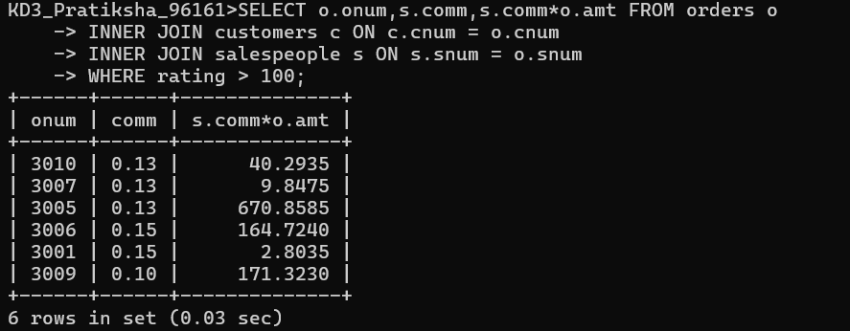
5) Write a query that produces all pairs of salespeople who are
living in the same city. Exclude combinations of salespeople with
themselves as well as duplicate rows with the order reversed.
